**WEEK 8**

**1BM21CS198**

**Query 1**

select a.aname from aircraft a,certified c

where a.aid=c.aid and c.eid in (select eid from employee where salary>80000);

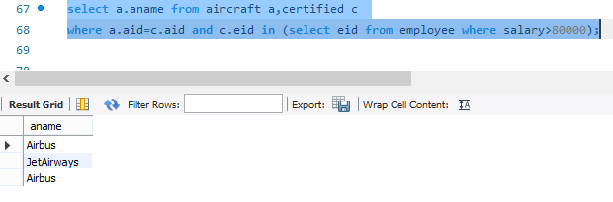

**Query 2**

select c.eid, max(a.cruisingrange) from certified c, aircraft a

where a.aid in (select aid from certified c1 where c1.eid=c.eid)

group by c.eid having count(c.eid)>=3;

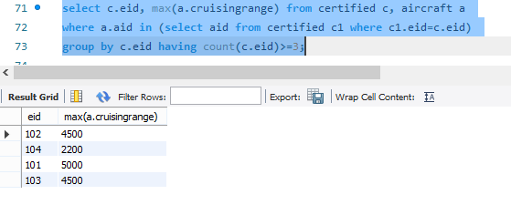

**Query 3**

select ename from employee

where salary<(select min(price) from flights where place_from='Bengaluru' and place_to='Frankfurt');

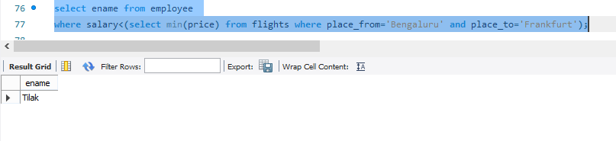

**Query 4**

select distinct e.ename from employee e, certified c

where e.eid=c.eid and c.aid in (select aid from aircraft where aname='Boeing');

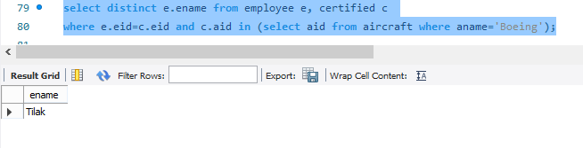

**Query 5**

select aid from aircraft

where cruisingrange > all(select distance from flights

where place_from='Bengaluru' and place_to='Delhi');

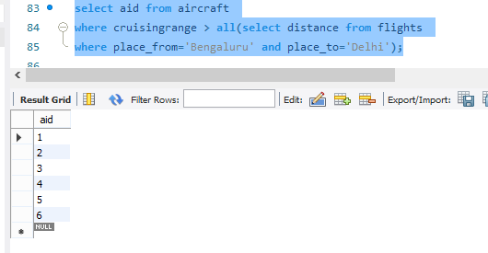

**Query 6**

select a.aid,a.aname,avg(e.salary)

from aircraft a,employee e,certified c

where a.aid=c.aid and

e.eid=c.eid

and a.cruisingrange>1000

group by a.aid;

